* [Careers Portal](https://classroom.udacity.com/career/main)

**Student Hub**

[All Threads](https://study-hall.udacity.com/threads)

**STUDENT COMMUNITIES**

[Full Stack Web Developer](https://study-hall.udacity.com/rooms/community:nd004:en-us-general?contextType=room)

[Intro to Programming](https://study-hall.udacity.com/rooms/community:nd000:en-us-general?contextType=room)

[Udacity Mentorship](https://study-hall.udacity.com/rooms/community:nd050:en-us-general?contextType=room)

**MENTORED PROJECTS**

***NANODEGREE TITLE*FULL STACK WEB DEVELOPER**

[Project: Logs Analysis](https://study-hall.udacity.com/rooms/community:nd004:617415-project-195?contextType=room)

[Project: Item Catalog](https://study-hall.udacity.com/rooms/community:nd004:617415-project-5?contextType=room)

[Project: Linux Server Configuration](https://study-hall.udacity.com/rooms/community:nd004:617415-project-7?contextType=room)

**DIRECT MESSAGES**

[User is offline](https://study-hall.udacity.com/conversations/community:conversation:256568591-5325919944?contextType=room)

[Steven W](https://study-hall.udacity.com/conversations/community:conversation:256568591-5325919944?contextType=room)

**[VIEW ALL MESSAGES](https://study-hall.udacity.com/conversations)**

**Thread**

in Project: Item Catalog

[*Close Sidebar*](https://study-hall.udacity.com/rooms/community:nd004:617415-project-5/community:thread-5325919944-644573?contextType=room)

JUMP TO RECENTCLOSE

**Peter V.**

**11:18 AM**

I have completed Logs Analysis and am working towards Item Catalog. I am a bit aggravated that the examples, i.e. Webserver.py, are written for Python 2. I have had some good work updating this file to Python 3, but I am stymied now that I am trying to add POST capability. I can see where someone in the past had the same issue, but the answer was to use Python 2. That just seems like a copout. Can I get a mentor to help me to get webserver.py runs in Python3? My latest attempt, webserver1.py is in github; <https://github.com/PeterVanLoon/Webserver.git>

* **TODAY**
  + - [**Zeeshan A.**](https://study-hall.udacity.com/rooms/community:nd004:617415-project-5/community:thread-5325919944-644573?contextType=profile&profileId=u11324)

**Mentor**

**11:19 AM**

Excellent [**@PeterV**](https://study-hall.udacity.com/rooms/community:nd004:617415-project-5/community:thread-5325919944-644573?contextType=profile&profileId=u11324). Best of luck with ItemCatalog. Let us know if you get stuck and need help

* + - [**Peter V.**](https://study-hall.udacity.com/rooms/community:nd004:617415-project-5/community:thread-5325919944-644573?contextType=profile&profileId=u11324)

**11:26 AM**

I could use some help updating that damned webserver.py file to run on Python 3.

* + - [**Zeeshan A.**](https://study-hall.udacity.com/rooms/community:nd004:617415-project-5/community:thread-5325919944-644573?contextType=profile&profileId=u11324)

**Mentor**

**11:34 AM**

Sure. Let me have a look at it

* + - [**Peter V.**](https://study-hall.udacity.com/rooms/community:nd004:617415-project-5/community:thread-5325919944-644573?contextType=profile&profileId=u11324)

**11:36 AM**

I am able to get the "GET" to work. The issue lies, I think, somewhere in the Submit functionality. I say this because I get the 200 and print out when I do the inital GET, but when I hit submit after putting something in the box, I get nothing but blank screen

* + - [**Peter V.**](https://study-hall.udacity.com/rooms/community:nd004:617415-project-5/community:thread-5325919944-644573?contextType=profile&profileId=u11324)

**11:39 AM**

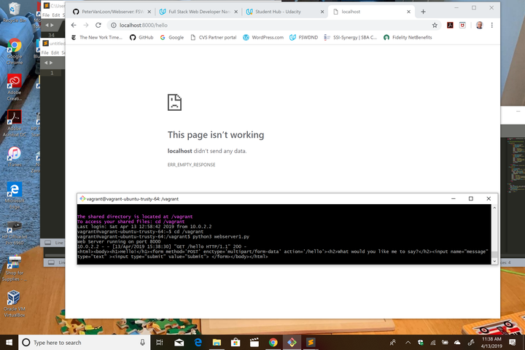

* + - This is what I get after I hit Submit, you can see the GET worked, but I would have expected the form to print on the Screen as the POST functionality works.
    - Thanks Zeeshan - I appreciate another set of eyes on this. I do not want to just "use Python 2".
    - [**Zeeshan A.**](https://study-hall.udacity.com/rooms/community:nd004:617415-project-5/community:thread-5325919944-644573?contextType=profile&profileId=u11324)

**Mentor**

**11:52 AM**

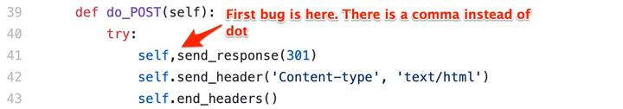

* + - [**Peter V.**](https://study-hall.udacity.com/rooms/community:nd004:617415-project-5/community:thread-5325919944-644573?contextType=profile&profileId=u11324)

**12:18 PM**

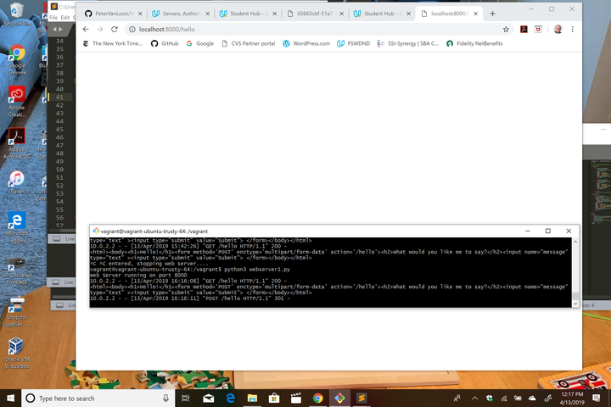

* + - I corrected that, and now I get the 301 but that is it.
    - [**Zeeshan A.**](https://study-hall.udacity.com/rooms/community:nd004:617415-project-5/community:thread-5325919944-644573?contextType=profile&profileId=u11324)

**Mentor**

**12:18 PM**

Replace your do_POST with following code:

def do_POST(self):

try:

self.send_response(301) # Compare this line with your code

self.send_header('Content-type', 'text/html')

self.end_headers()

ctype, pdict = cgi.parse_header(

self.headers.get('Content-type')) # Compare this line with your code - getheader -> get

pdict['boundary'] = bytes(pdict['boundary'], "utf-8") # This is new

if ctype == 'multipart/form-data': # Compare this line with your code - form data -> form-data

fields = cgi.parse_multipart(self.rfile, pdict) # Compare this line with your code - self, rfile -> self.rfile

messagecontent = fields.get('message')

output = ""

output += "<html><body>"

output += "<h2> Okay, how about this you fools?:</h2>"

output += "<h1> %s </h1>" % messagecontent[0].decode()

output += "<form method='POST' enctype='multipart/form-data' action='/hello'><h2>What should I say?</h2><input name='message'type='text' ><input type='submit' value='Submit'></form>"

output += "</body></html>"

self.wfile.write(output.encode('utf-8')) # Compare this line with your code

print (output)

except:

pass

* + - [**Peter V.**](https://study-hall.udacity.com/rooms/community:nd004:617415-project-5/community:thread-5325919944-644573?contextType=profile&profileId=u11324)

**12:18 PM**

Nothing but white space comes back

* + - I see that my error must be in the POST
    - [**Zeeshan A.**](https://study-hall.udacity.com/rooms/community:nd004:617415-project-5/community:thread-5325919944-644573?contextType=profile&profileId=u11324)

**Mentor**

**12:19 PM**

Notice the comments above

* + - [**Peter V.**](https://study-hall.udacity.com/rooms/community:nd004:617415-project-5/community:thread-5325919944-644573?contextType=profile&profileId=u11324)

**12:21 PM**

I see what you did. Can you tell me, in general terms, why?

* + - I think I need to understand the CGI library, ctype, and pdict
    - [**Peter V.**](https://study-hall.udacity.com/rooms/community:nd004:617415-project-5/community:thread-5325919944-644573?contextType=profile&profileId=u11324)

**12:25 PM**

Yes, I see your comments. I think my big issues were small - lack of attention to detail around commas and periods.

* + - [**Zeeshan A.**](https://study-hall.udacity.com/rooms/community:nd004:617415-project-5/community:thread-5325919944-644573?contextType=profile&profileId=u11324)

**Mentor**

**12:25 PM**

Some of the issues were just the syntax and code related bugs

* + - The line that I added is because Python is handling strings differently in version 3 as compared to version 2
    - So i added the line to convert boundary property in content type header to bytes, otherwise it would raise a type error
    - [**Peter V.**](https://study-hall.udacity.com/rooms/community:nd004:617415-project-5/community:thread-5325919944-644573?contextType=profile&profileId=u11324)

**12:27 PM**

Got it. Also, that utf-8 is the default, I understand - but it helps keep me honest

* + - [**Zeeshan A.**](https://study-hall.udacity.com/rooms/community:nd004:617415-project-5/community:thread-5325919944-644573?contextType=profile&profileId=u11324)

**Mentor**

**12:27 PM**

Yes, i added that just to clarify

* + - You just need to be more careful while writing code
    - [**Peter V.**](https://study-hall.udacity.com/rooms/community:nd004:617415-project-5/community:thread-5325919944-644573?contextType=profile&profileId=u11324)

**12:28 PM**

"boundary property" is new to me - I will chase down documentation on that in addition to the CGI documentation

* + - [**Zeeshan A.**](https://study-hall.udacity.com/rooms/community:nd004:617415-project-5/community:thread-5325919944-644573?contextType=profile&profileId=u11324)

**Mentor**

**12:29 PM**

issues like confusing comma with dot might not be easier and intuitive to find but those are some of the issues which let most developers pull their hair

* + - [**Peter V.**](https://study-hall.udacity.com/rooms/community:nd004:617415-project-5/community:thread-5325919944-644573?contextType=profile&profileId=u11324)

**12:29 PM**

Understood, and thank you.

* + - [**Zeeshan A.**](https://study-hall.udacity.com/rooms/community:nd004:617415-project-5/community:thread-5325919944-644573?contextType=profile&profileId=u11324)

**Mentor**

**12:30 PM**

this exercise is mostly for your understanding of how it works under the hood. Later when you start building learning advanced topics, you'll learn the packages and libraries that keep these details abstract so you dont need to worry about CGI lib that much

* + - For example, when you use Flask server, all of this will be taken care by Flask and syntax will become much simple
    - [**Peter V.**](https://study-hall.udacity.com/rooms/community:nd004:617415-project-5/community:thread-5325919944-644573?contextType=profile&profileId=u11324)

**12:32 PM**

I appreicate the value of knowing the detail. Thinking in the abstract is a skill I am still trying to master

* + - Zeeshan - how can I give you an "upvote". I reallyappreciate your help.
    - [**Zeeshan A.**](https://study-hall.udacity.com/rooms/community:nd004:617415-project-5/community:thread-5325919944-644573?contextType=profile&profileId=u11324)

**Mentor**

**12:35 PM**

You can reflect it in the feedback when you are asked at some point :)

* + - [**Peter V.**](https://study-hall.udacity.com/rooms/community:nd004:617415-project-5/community:thread-5325919944-644573?contextType=profile&profileId=u11324)

**12:36 PM**

I will do that - Thanks for explaining what you did in the comments.

* + - [**Zeeshan A.**](https://study-hall.udacity.com/rooms/community:nd004:617415-project-5/community:thread-5325919944-644573?contextType=profile&profileId=u11324)

**Mentor**

**12:36 PM**

Always happy to help!